Peripheral Vision Validation

Name_______________________________________________________

1. Complete the table below for the investigation your group carried out on the difference in the angle at which movement can be detected, and the angle at which the colour of an object can be detected, in the peripheral vision of humans

|  |  |
| --- | --- |
| Aspect | What was it for your investigation? |
| Hypothesis |  |
| Independent variable |  |
| Dependent variable |  |

1. marks)
2. Why was peripheral vision essential to early Homo sapiens?

(2 marks)

1. What is the range of peripheral vision for humans?

(1 mark)

1. What are the two main types of photoreceptors found in humans?
2. marks)
3. Where is each of the two types of photoreceptors located in humans?

(4marks)

1. An investigation was done to find if the flexibility in the lower back and legs is different between people younger than 20 years of age, compared to people over 40 years of age. The people being tested were asked to sit on the floor and reach forward. The distance that the people could reach past their toes was measured.
2. For this investigation what is the independent variable?

(1mark)

1. What is the dependent variable?

(1 mark)

1. State a hypothesis for this investigation. (2 marks)
2. Here are the results of this investigation.

Complete the table below

|  |  |  |
| --- | --- | --- |
| Name | Age  (years) | Flexibility  (cm) |
| John | 19 | 10 |
| Jim | 17 | 2 |
| Jenny | 18 | 7 |
| Jack | 18 | 12 |
| Annie | 19 | 9 |
| Total | |  |
| Average | |  |
| Craig | 41 | 0 |
| Sandy | 44 | 2 |
| Lam | 43 | 14 |
| Jasper | 41 | 4 |
| Rodd | 47 | 4 |
| Total | |  |
| Average | |  |

(1 Mark)

1. Draw a suitable graph of the results in the previous table.
2. marks)
3. How could the results have been made more accurate? (1 mark)
4. What is your conclusion for the experiment above?

(1 mark)

1. Using the graph you drew, would it be possible to do accurate extrapolation for people of other age groups? Explain why.
2. marks)
3. Use this graph to answer the questions that follow

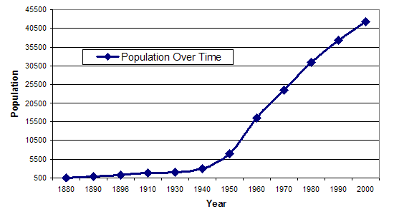

1. What will the population be in 2010?

(1 mark)

1. Was your answer to question 7a an example of extrapolation or interpolation? Give a reason for your choice.

(2 marks)

1. What was the population in 1965?

(1 marks)

1. Was your answer to question 7c an example of extrapolation or interpolation? Give a reason for your choice.

(2 marks)

1. Which was more likely to be correct, your answer to question 3a or 3c? Give a reason for your answer.

(2 marks)

1. Look at the results below. They are the results for a test (experimental) sample group whose blood pressure was being observed after a 6 month training plan, where each person was made to walk for 1 hour a day. Use the data to answer the questions that follow.

|  |  |  |  |
| --- | --- | --- | --- |
| Name of test person | Age | Receiving blood pressure medication | Blood pressure  After 6 months training |
| Bob | 22 | No | 110/70 |
| Bill | 21 | No | 120/73 |
| Aaron | 23 | No | 122/70 |
| Jim | 58 | No | 124/80 |
| Jane | 23 | No | 130/70 |
| Jill | 21 | Yes | 117/70 |
| Sarah | 25 | No | 105/70 |
| Sammy | 20 | No | 120/70 |
| Jack | 22 | No | 114/70 |
| June | 21 | No | 160/90 |
| Terry | 22 | No | 126/70 |
| Trudy | 23 | No | 127/70 |

1. What is missing from the table?

(4 marks)

1. Which result appears to be an outlier? Give a reason for your choice.

(2 marks)

1. Apart from the outlier, which person should not have his/her results counted? Give a reason for your answer.

(2 marks)

1. What must be done with this data before constructing a graph of results? Why should this be done?

(2 marks)

/46 marks